


SOFTWARE DESIGN SPECIFICATION
Cloud Computing
Automated MongoDB Backup and Recovery System on AWS

Created By: | Pranit Jejurikar | Approved By: | Domain Lead
Created On: | 05-Jun-2026 | Approved On: | 07-Jun-2026

Page left blank intentionally

INDEX
1 PURPOSE 2
2 PROJECT SCOPE 2
3 SYSTEM OVERVIEW 2
4 DESIGN CONSIDERATIONS 2
4.1 Requirements 2
4.2 Assumptions 3
4.3 Dependencies 3
5 SYSTEM ARCHITECTURE 3
5.1 Architectural Strategies 4
5.2 Structure & Relationships 4
6 DETAILED DESCRIPTION OF COMPONENTS 5
7 INTEGRATION 6
8 APPENDICES 1
8.1 Appendix A – Detailed Description of Components 1

General Instructions for using the Live Project POC Document
- This template and the subsequent document created using this template is a confidential document and is the intellectual property of Cloud Counselage Pvt. Ltd. Circulating it outside of the organisation without the consent of Cloud Counselage Pvt. Ltd. is the breach of company policies and will lead to legal actions
- The Design Specification of a software forms the basis of development of software
- The text between inequality (< >) is to be replaced by relevant text
- Please remove the yellow highlight on the Text between the inequality (< >). This is done to help you notice the text to be changed/replaced
- The text in italics highlighted in grey is just for reference and should be removed after adding the relevant text

PURPOSE
The purpose of this Software Design Specification (SDS) document is to describe the design and implementation details of the Automated MongoDB Backup and Recovery System on AWS. This document provides a detailed breakdown of the software components, architecture, workflows, integrations, and deployment strategy required to automate MongoDB backups and restoration.

PROJECT SCOPE
The scope of the Automated MongoDB Backup and Recovery System on AWS includes automated database backup creation, secure cloud storage, backup scheduling, monitoring, and database restoration.
The system allows users to automate MongoDB backups using mongodump, store backup files in Amazon S3, and restore data using mongorestore.
The solution reduces manual effort, improves reliability, and enhances disaster recovery capabilities.

SYSTEM OVERVIEW
The system consists of the following components:
• MongoDB Database
• Backup Script Module
• Cron Scheduler
• AWS CLI
• Amazon S3 Storage
• Restore Module
• Logging Module
The system automatically creates scheduled database backups, uploads them to Amazon S3, and allows restoration whenever required.

DESIGN CONSIDERATIONS

Requirements
• Automated backup generation
• Scheduled execution
• Secure backup storage
• Backup verification
• Restore functionality
• Logging and monitoringThe list of components

Assumptions
• AWS services are available.
• MongoDB is installed correctly.
• AWS credentials are configured.
• Internet connectivity exists.
• S3 bucket is accessible.

Dependencies
• AWS EC2
• MongoDB Community Edition
• Amazon S3
• AWS CLI
• Cron Scheduler
• Linux Operating System

SYSTEM ARCHITECTURE
The solution follows a simple cloud-based architecture for automated MongoDB backup and recovery. The architecture integrates MongoDB, a Bash backup script, AWS CLI, Amazon S3 storage, Cron Scheduler, and MongoDB restore utilities to provide secure and automated database protection. Defines structure of a system:
- Defines behaviour of a system
- Defines component relationship
- Defines communication structure
- Balances stakeholder’s needs
- Influences team structure
- Focuses on significant elements
- Captures early design decisions

Below some important characteristics which are commonly considered are explained.
Operational Architecture Characteristics:
- Availability
- Performance
- Reliability
- Low fault tolerance
- Scalability

Structural Architecture Characteristics:
- Configurability
- Extensibility
- Supportability
- Portability
- Maintainability

Cross-Cutting Architecture Characteristics:
- Accessibility
- Security
- Usability
- Privacy
- Feasibility

Architectural Strategies
Major Components:
- MongoDB Database
- Backup Script Module
- Scheduler Module (Cron)
- AWS CLI Module
- Amazon S3 Storage Module
- Restore Module
- Logging Module

Structure & Relationships

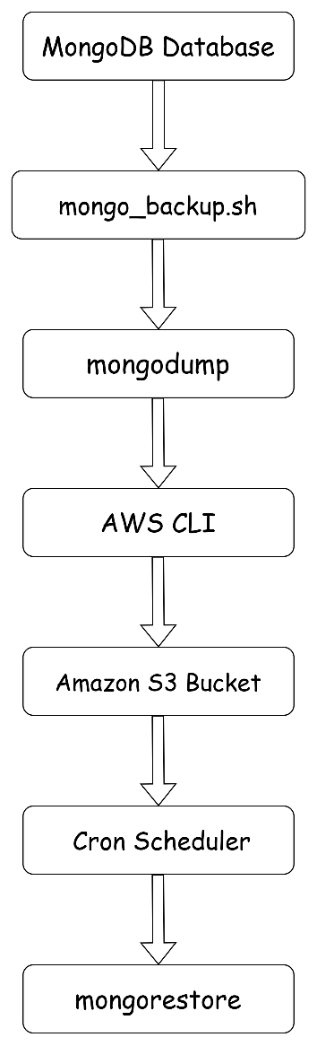

DETAILED DESCRIPTION OF COMPONENTS
Identification | MongoDB Database
Type | Database
Purpose | Stores application data.
Subordinates | Collections and Documents
Dependencies | MongoDB Server.
Interfaces | Backup Script Module.
Resources | EC2 Storage.
Processing | Reads and writes database records.
Data | MongoDB Collections.

INTEGRATIONS
The system integrates with:

• MongoDB Community Edition
• AWS EC2 Instance
• Amazon S3 Storage Service
• AWS CLI
• Linux Cron Scheduler

Integration Process:

- MongoDB data is backed up using mongodump.
- Backup script is executed automatically by Cron.
- AWS CLI uploads backup files to Amazon S3.
- Backup files are stored securely in cloud storage.
- mongorestore is used to restore backup data when required.
- Restoration is performed using mongorestore when recovery is required.

APPENDICES

Appendix A – Detailed Description of Components
Component 1
Identification | Backup Script Module
Type | Bash Script
Purpose | Automates MongoDB backup creation.
Subordinates | - Backup Directory Creation  - mongodump Execution  - Amazon S3 Upload  - Log Generation  - Local Cleanup
Dependencies | - MongoDB, AWS CLI
Interfaces | MongoDB Database, Amazon S3
Resources | EC2 InstanceEC2 Instance
Processing | Executes mongodump and uploads backups.
Data | Backup archive files
Component 2
Identification | Amazon S3 Storage
Type | Cloud Storage
Purpose | Stores backup archives securely.
Subordinates | Backup Archive Storage  Backup File Management
Dependencies | AWS CLI
Interfaces | Backup Script
Resources | S3 Bucket
Processing | Receives uploaded backup files.
Data | MongoDB backup archives

Component 3
Identification | Restore Module
Type | MongoDB Utility
Purpose | Restores backup data.
Subordinates | Backup Archive Reading, Collection Restoration, Data Recovery
Dependencies | mongorestore
Interfaces | Backup Archive
Resources | EC2
Processing | Restores collections.
Data | MongoDB Documents

